
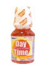  Wholesale Allergy, Cough, & Cold | 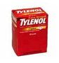  Bulk Analgesics &  Pain Relievers | 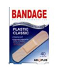  Bulk Bandages &  Pill Organizers | 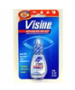  Wholesale Eye & Ear Care
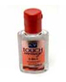  Wholesale Sexual Wellness | 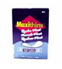  Wholesale Feminine Hygiene | 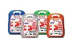  Wholesale First Aid Products & Kits | 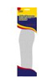  Bulk Foot Care Products
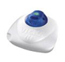  Wholesale Medical Equipment | 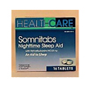  Wholesale Sleep Aids | 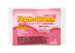  Wholesale Stomach Remedies | 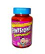  Bulk Vitamins & Minerals

