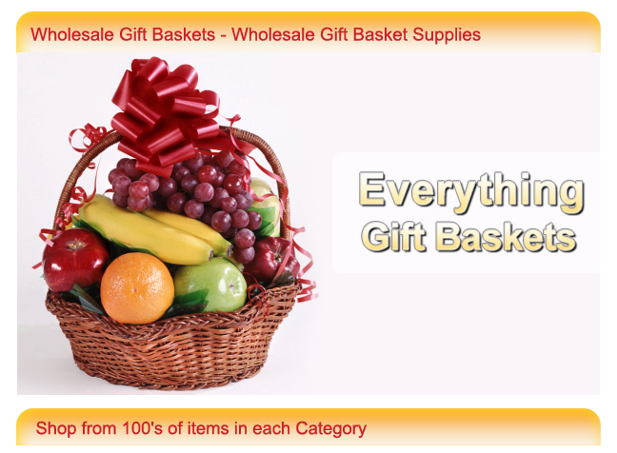

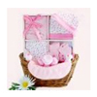  Bulk Baby Gift Baskets | 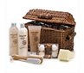  Wholesale Bath & Lotion Gift Sets | 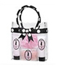  Wholesale Span &  Candle Gift Sets | 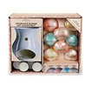  Bulk Gift Baskets  for Her
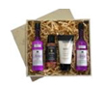  Bulk Gift Baskets  & Supplies | 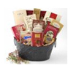  Wholesale Gourmet  Gift Baskets | 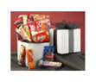  Snack Food Gift Baskets | 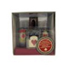  Bulk Gift Baskets  for Him

