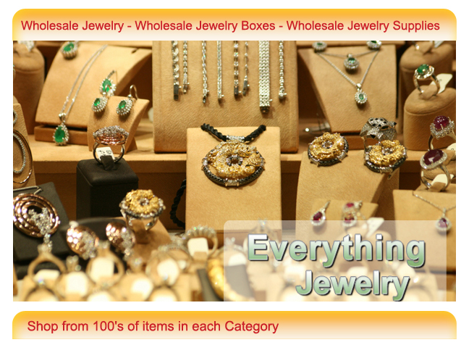
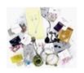  Jewelry Assortment  & Lots | 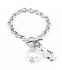  Wholesale Bracelets | 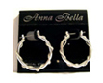  Wholesale Earrings | 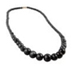  Wholesale Necklaces
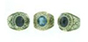  Bulk Men’s Jewelry | 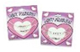  Cheap Kid’s Jewelry | 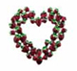  Wholesale Pins & Brooches | 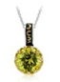  Bulk Pendants  & Charms
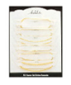  Cheap Wholesale Anklets | 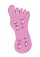  Wholesale Jewelry Boxes | 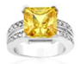  Wholesale Golf Jewelry | 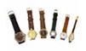  Jewelry Accessories & Repair

